<https://github.com/prithvivenkatachalapathy/PythonDockerFlaskUsingWebForms>

1. TABLE DATA IN PYCHARM

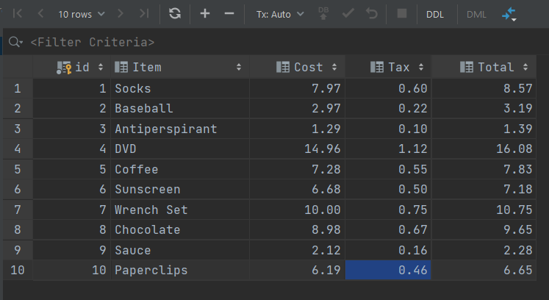

1. DISPLAYING IN WEB PAGE

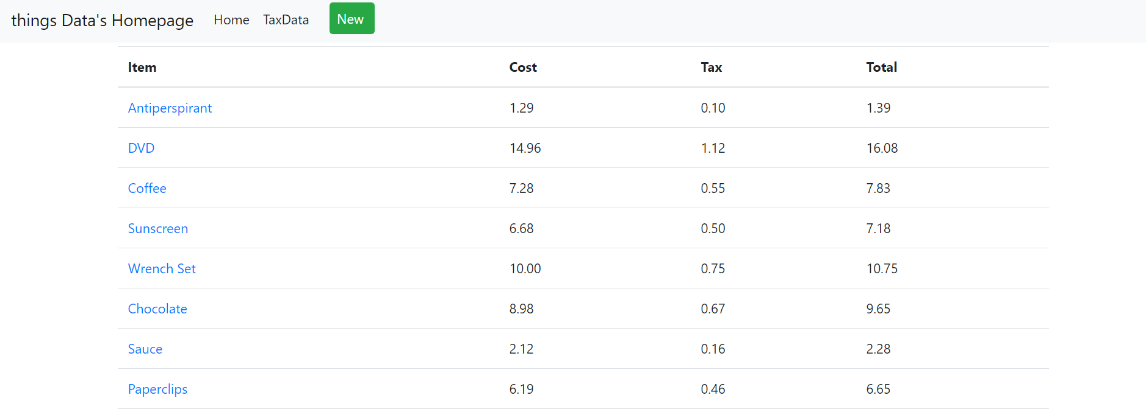

1. DISPLAYING A RECORD

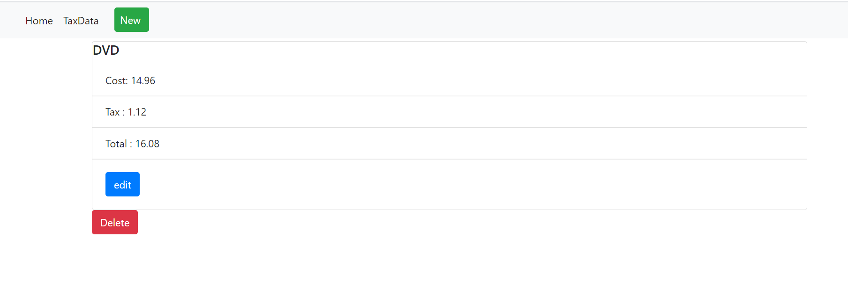

1. ADDING NEW RECORD

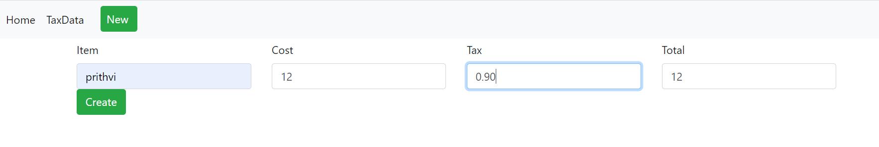

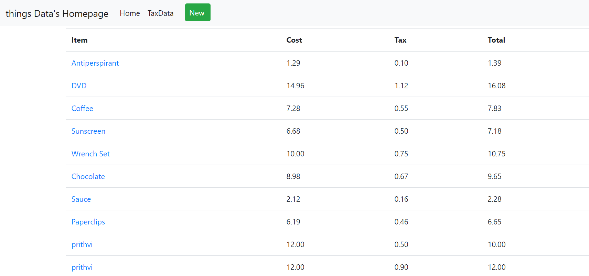

1. UPDATING RECORD

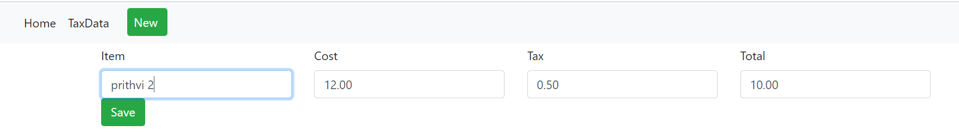

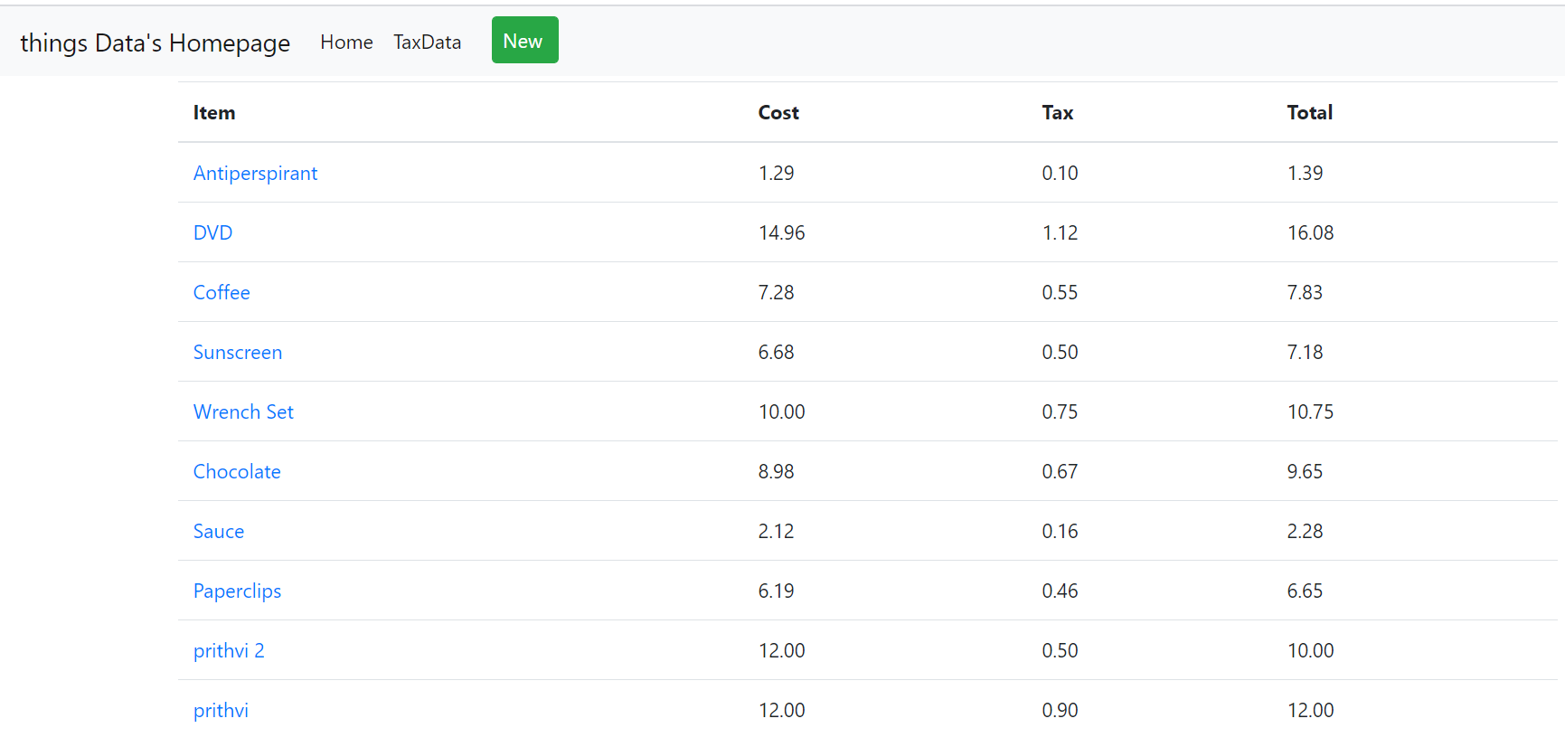

1. DELETING A RECORD

